**UNIVERSITY OF TEXAS AT AUSTIN**

**PGE 381L - ADVANCED PETROPHYSICS FALL 2023**

**Name: Renato Espirito Basso Poli**

**UT EID: rep2656 09/07/2023**

**Homework Assignment No. 1**

***Question 1:*** *Please download the Excel documents “SandstoneData_HW1” and “CarbonateData_HW1”. These documents include porosity and permeability core measurements in a sandstone and a carbonate formation. Answer the following questions:*

1. *Prepare permeability-porosity cross plots for these two data sets. The x and y axes need to be in logarithmic scale.*

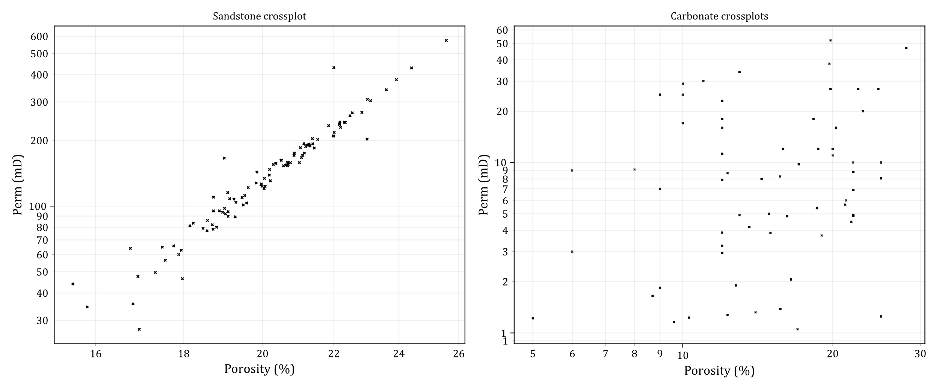

1. *Can you estimate permeability at a given depth in the* ***sandstone*** *formation, where porosity is estimated to be 20%? There is no core measurement available at this depth. If yes, describe the method you design to estimate permeability, and write the estimated permeability below. If no, explain the reason(s).*

Yes, we can. As we can see from the previous crossplots, there is a clear correlation between porosity and permeability in the sandstone formation. I made the estimation fitting an exponential curve to the data (I used the “*curve_fit”* routine from Python Scipy library).

$$k=2.7513 ({10}^{-6}) . ϕ^{5.9017}$$

where $ϕ$ is the porosity in $\%$ and $k$ is the permeability in $mD$. The plot below shows the results. The estimated permeability at is .

1. *Can you estimate permeability at a given depth in the carbonate formation, where porosity is estimated to be 12.5%? There is no core measurement available at this depth. If yes, describe the method you design to estimate permeability, and write the estimated permeability below. If no, explain the reason(s).*

No, that is not possible with the information given. The crossplot $k-ϕ$ does not show any acceptable correlation between the two variables.

***Question 2:*** *A petrophysicist is evaluating the possibility of using micro-CT scan imaging for quantifying porosity of a given rock type in a spatially heterogeneous and tight carbonate formation. Would you approve this method? Write at least two reasons to support your decision.*

This methodology must be used carefully. While it may gather valuable data to understand the formation, the porosity found in such measurements cannot be directly extrapolated to the field, and does not mean much in carbonates.

One reason is that such a small sample is probably not representative of the whole reservoir, as the heterogeneity varies spatially in larger scales.

Another reason is that secondary porosity in carbonates is usually more important than primary porosity, especially while assessing overall reservoir quality and capacity to flow. Moreover, the major sources of such porosity are fracutres, solution and chemical replacement, which occur in metric to kilometric scales and won’t be properly assessed in micro CT imaging.

That means that the porosity observed in small samples might even not be part of the interconnected macro porous network, which controls the fluid flow in the reservoir. Instead, the petrophysicist should be more concerned in understanding this network its volume, permeability and flow capacity, with suitable methods.

***Question 3:*** *How do permeability and porosity vary vertically in a fining-upward sequence? Explain your answers. You can assume same spherical shapes and packing for the grains throughout this sequence. Write your assumptions.*

Considering a sandstone with well sorted spherical grains, negligible secondary porosity and uniform packing (ex: cubic packing), we can infer the total porosity will be approximately homogeneous throughout the sequence. Permeability, however, will be reduced towards the top of the sequence, where finer grains are found. The reason is that the smaller grains will set narrower spaces to flow, with smaller porous body and tighter throats.

***Question 4:*** *We have two carbonate core plugs in the laboratory. Table 1 summarizes core measurements for these two rock samples.*

|  |  |
| --- | --- |
| ***Table 1:*** *Core properties measured in the laboratory* |  |
| ***Porosity*** | ***Permeability*** |
| ***Rock A*** *0.15* | *200 md* |
| ***Rock B*** *0.15* | *10 md* |

*What could be the reason(s) for such different permeability values while porosity is the same in these two rock samples?*

The pore structure in carbonates is typically heterogeneous built from secondary mechanisms. Thus, while the voids in rick A might be highly connected, the voids in rock B might be poorly connected. As seen earlier in this report, porosity and permeability in carbonates show typically weak or no correlation, and two samples with the same porosity might show distinct permeability and capacity to flow.

***Question 5 (Problem 1.1 from your textbook):*** *We received three core samples in the laboratory. We know that one of them is a quartz sandstone. The second one is a limestone and the third one is a dolomite. They are, however, not labeled. How would you identify them? Describe the experiments you would design to label these samples correctly.*

The first thing to do is to look at the overall attributes of the samples. The quartz sandstone will probably show more homogeneous grain distribution, typically a light white color, while the carbonates may show a variety of pore size and minerals of different sizes and colors, perhaps with visible vugs or fractures. We could also estimate the grain density, the higher density will likely be the dolomite sample, although impurities may mask the result. The chemical reactivity of the samples could be tested by small drops of acid, which would not react with the quartz sandstone, but would show a fast reaction with the carbonates.

We could also analyze the micro-structure of the samples using micro-CT images or thin sections using a microscope. The quartz sandstone will likely show predominant primary porosity with grains well defined, without dissolution or chemical activity. The limestone and dolomite would show a more complex pore network, with relevant secondary porosity and grains with distinctive shapes. Moreover, by investigating the minerals composition of the samples, we would identify the dolomitization process and distinguish between the dolomite and the limestone.

***Question 6:*** *I have slabbed core samples in the laboratory for the depth interval of 9000ft to 9500ft and plan to measure porosity and permeability of the formation at the depth of 9200ft. Is the direction of the core plug that I cut for the permeability measurements important? What about porosity? Write your answer for the following situations. Please explain your answer.*

1. Tela de computador com texto preto sobre fundo branco

   Descrição gerada automaticamente*Homogeneous and isotropic sandstone*

The direction of the core plug is not so important as the measurements would be very similar in any direction due to the isotropic and homogeneous nature of the rock.

1. *Cross-bedded sandstone*

In this case, although the sampling direction is not relevant for porosity estimation, the direction of the curring will definitely be relevant for permeability estimation as each bedding shows singular flow behavior. We must have in mind that the principal permeability direction may not be obvious and to plan the sampling.

1. *Thinly-bedded laminated shaly sandstone*

For thinly layered rocks, we can expect lamination at the plug scale. Parallel to the lamination, higher permeabilities are expected, while lower permeabilities are e xpected perpendicularly. Both measurements make sense to characterize the reservoir, as long as they are properly interpreted. For porosity, as long as the laminations occur in sufficient smaller scale than the sample, the estimations will be similar in any cutting direction.

1. Uma imagem contendo tesoura, ferramenta

   Descrição gerada automaticamente*Dispersed shaly sandstone*

Dispersed shale reduce the overall permeability of the sample, but are not likely to influence on isotropy. Therefore, the direction of the cutting is less relevant, both for permeability and for porosity measurements.

1. *Organic-rich mudrock*

In this case, organic matter and kerogen occupy a large portion of the pore space. Porosity and permeability estimations will reflect such tight environment. It is not to expect relevant anisotropic behavior, so the direction of the cuttings are not necessarily relevant, unless data and inspection of the formation show a laminated patterns.

**Optional Question:**

***Question 7:*** *How does size and density of grains affect their deposition? Support your answer with simplified quantitative calculations. Can you use your calculations to explain dominant grain deposition trends in shallow and deep marine environments? List the assumption you made in your calculations.*

*Hint: Consider the forces applied on the grains (e.g., Drag (quantify using Stokes' law) and buoyant forces) at equilibrium. Then, calculate the relative velocity between grains and liquid as a function of grain density, fluid viscosity, and radius of grains.*

According to the textbook, “sandstones are composed of fragmented materials which have been transported by water currents and which have been subjected to varying degrees of wave and current action during transport and during deposition”. We must therefore study the forces acting on this environment to understand the deposition profiles of a given sandstone formation.

Approximating particles’ geometries to spheres, Stokes law states that the viscosity forces are given by:

$$F_{v}=6πμrv$$

where $r$ is the radius, $μ$ is the viscosity and $v$ is the fluid velocity relative to the object. The resulting downward forces $F_{v}$ are given by:

$$F_{v}=V_{particle} ρ_{particle} g- ρ_{w} V_{particle} g$$

$$F_{v}=\frac{4π}{3}r^{3} g (ρ_{particle}-ρ_{w})$$

where $ρ$ stands for density, $g$ is gravity, $V$ is the particle volume and $r$ is the particle radius. We can now estimate the fluid velocity relative to the object as a function of the radius and density of the particle:

$$\frac{4π}{3}r^{3} g \left(ρ_{particle}-ρ_{w}\right)=6πμrv$$

$$v_{v}=\frac{2}{9}\frac{r^{2} g}{μ} \left(ρ_{particle}-ρ_{w}\right)$$

That means that the upward fluid velocity $v_{v}$ relative to the particle is proportional to the particle radius squared $r^{2}$ and to the particle density $ρ_{particle}$. Therefore, the larger and denser the particles are, the faster they drop relative to the fluid, and horizontal friction forces will stop them sooner as the water currents loose energy.

In brief, in shallow environments, where currents and waves provide higher transport energy, smaller grains will be transported with the water current away from the larger grains. In such environments, larger grains will deposit generating cleaner, well sorted porous sandstones. In deep marine environments, on the other hand, as water current energy lowers in calm, smaller particles deposit and we expect tighter sandstones, with less porosity and less permeability.

**Appendix A - Source code for Question 1.**

import pandas as pd

import numpy as np

import matplotlib.pyplot as plt

plt.style.use('default')   ## reset!

plt.style.use('paper.mplstyle')

df = pd.read_excel("SandstoneData_HW1.xlsx")

df["POR%"] = df.POR * 100

# Makes a regression

from scipy.optimize import curve_fit

def expFoo(x, a, b):

    return a * np.power(x, b)

popt, pcov = curve_fit(expFoo, df["POR%"], df.PERM)

perm_at_por20 = expFoo([20], *popt)

fig, [ax_ss, ax_cb] = plt.subplots(1,2)

fig.set_size_inches(12,5)

ax=ax_ss

df.plot.scatter("POR%", "PERM", marker='x', color='k', s=5, ax=ax)

# Plot curve fit

newX = np.logspace(1.2, 1.4, base=10)

ax.plot(newX, expFoo(newX, *popt))

# Plot point por = 20%

ax.scatter(20, perm_at_por20, marker='o', color='red', s=50)

x = 20

y = perm_at_por20[0]

ax.annotate(f"%.1f" % y, (x,y), xytext=(x+1, y-50), color="r",

    arrowprops = dict(  arrowstyle="->", connectionstyle="angle3,angleA=0,angleB=-90", color="r"))

ax.set_title("Sandstone crossplot")

ax.set_ylabel("Perm (mD)")

ax.set_xlabel("Porosity (%)")

ax.set_xscale('log')

ax.set_yscale('log')

from matplotlib.ticker import FormatStrFormatter

ax.xaxis.set_minor_formatter(FormatStrFormatter('%0.0f'))

ax.yaxis.set_minor_formatter(FormatStrFormatter("%0.0f"))

ax.yaxis.set_major_formatter(FormatStrFormatter("%0.0f"))

#

# CARBONATE DATA

#

df = pd.read_excel("CarbonateData_HW1.xlsx")

df["POR%"] = df.POR

ax = ax_cb

df.plot.scatter("POR%", "PERM", marker='x', color='k', s=3, ax=ax)

ax.set_title("Carbonate crossplots")

ax.set_ylabel("Perm (mD)")

ax.set_xlabel("Porosity (%)")

ax.set_xscale('log')

ax.set_yscale('log')

from matplotlib.ticker import FormatStrFormatter

ax.xaxis.set_minor_formatter(FormatStrFormatter('%0.0f'))

ax.xaxis.set_major_formatter(FormatStrFormatter('%0.0f'))

ax.yaxis.set_minor_formatter(FormatStrFormatter("%0.0f"))

ax.yaxis.set_major_formatter(FormatStrFormatter("%0.0f"))

#

# Export

#

fig.tight_layout()

fig.savefig("por_vs_perm.svg")